General Assembly 2 Friday December 18th

Synopsis: The Calvert Association of Student Councils held the 2nd general assembly of the year on Friday December 18th 2020. The meeting took place on Teams. During the meeting students from around the county were able to come together to attend exciting workshops and roundtables. Delegates also listened to some announcements from the SMOB and Mr. Goldstein.

Schools Present (Roll Call)

NHS | CHS | HHS | PHS | WHMS | CMS | NMS | PPMS | MCMS | SMS
Y | Y | Y | Y | Y | Y | Y | Y | Y | Y

Workshops and Round tables:
The workshops and round tables presented at this GA are the following.

Workshops
Study Skills and Organization
How to Ace an Interview
Public Speaking
Community Service
Controversial Conversations
What type of leader are you?
Community Service
Advocacy
Mental Health
Communication

Round Tables
Social Justice
Mental Health
Online Learning
Anti-Racism

CASC Newsletter
https://www.scribd.com/document/488553775/the-calvert-chronicles-volume-2-issue-1-2#download&from_embed

I. Call to Order
Thomas called the meeting to order at 9:06 am.

II. Roll Call
Thomas completed the roll call. All schools were present.

III. Workshop Round 1 (9:10 through 9:40)
Delegates attended their first round of workshops. The workshops ran from 9:10 to 9:40. Workshop topics listed above.

IV. Round Table One (9:45-10:05)
Delegates attended their first round table of the day. Round table topics listed above.

V. Round Table Two (10:10-10:30)
Delegates attended their second roundtable of the day.

VI. Break (10:30-10:35)
Students took a quick break and moved to the next round tables.

VII. Round Table Three (10:40-11:00)
Delegates attended their third roundtable of the day

VIII. Workshop Round Two (11:05-11:35)
Delegates attended their second workshop of the day.

Everyone was sent the evaluations.

IX. SMOB Report
Abby Setzfand gave the SMOB report.
- The Board of Education voted to send k-12 back by February
- A new board member will be added to the Board of education in 2021.
- SMOB Elections are coming up next general assembly. Ask to Abby if you're interested and she can give you some information

X. Officer Reports
The officer reports were cut because of a shortage of time but Destiny gave an update about some of the projects she has been working on.

Destiny gave a short report about her Caribbean Breeze well living campaign and 2020 Challenge

- Send Destiny your letters if you signed up for the Caribbean Breeze campaign
- The last day to send letters in was on Monday December 21

destiny.a.lewis.md@gmail.com

- Post on your Instagram story or take a video doing the 20 for 20 push up challenge for suicide prevention and mental health awareness.

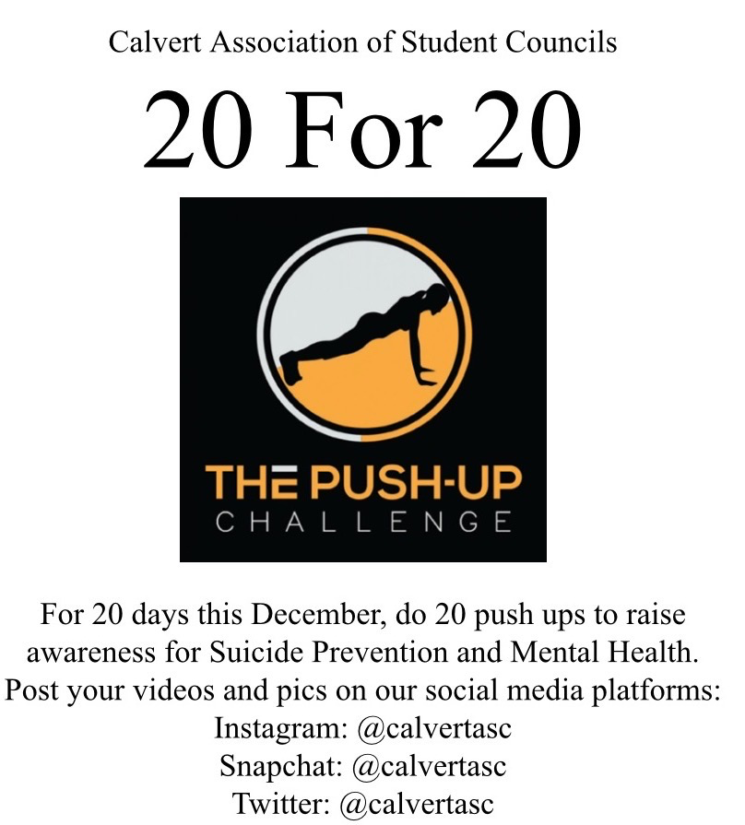

XI. Announcements

David
David showed everyone the general website for CASC and showed us all the things included on the website.
Calvertasc.weebly.com

XII. Advisor Report
Mr. Goldstein gave the advisor report.

- He reminded everyone to be kind, honest, and specific on their evaluations
- The next CASC Exec Board Meeting is on January 11th
Dr. Curry (superintendent) comes at 6 and the Executive board meeting starts at 6:30pm.

SMOB applications and information should be sent out some time next week (week of the 21st)
You must be….
- A Junior or senior
- Eligible for afterschool activities (good academic standing)

The next general assembly is tentatively Friday February 19th.
SMOB elections will use an electoral system
- 2 votes for each middle school and 4 votes for each high school
- A candidate must get half plus one of the votes to win, if not there will be a runoff with less candidates
- Its in the works to get the Board of Education building for in-person speeches that will be live streamed for the GA
- The schools will participate in caucus meetings through teams with their school to vote.

Legislative session is on February 20th
- Registration opens January 15th and closes February 7th
- At this MASC event students vote for the state SMOB
- To attend this event you must register through your school
- Registration to be a workshop presenter at legislative session ended Monday December 21st.

Mr. Goldstein thanked everyone for their patience and all the workshop and round table presenters.

Thomas Adjourned the meeting at 11:56 am

