CASC Meeting April
Synopsis: The Calvert Association of Student Councils' meeting was held on Monday April 19th. The meeting took place on teams at 6:30pm. During the meeting students reviewed the plans for the fourth general assembly of the year on Friday April 23rd. They also discussed an upcoming community service project. Lastly Mr.Goldstein gave his advisor report.

Present
More than 7 people not from the executive board were at the CASC meeting.

Call to Order
The meeting was called to order at 6:30pm on April 19th by the president.

Approval of Agenda
Thomas asked for a motion to approve the agenda and it was passed.

Old Business
April 23 General Assembly

- Mr. Goldstein is still in the process of making the teams meetings for the general assembly. Three schools have sent in their delegations but he's missing the rest of the schools. Many schools said they were waiting on a list of workshops.
- The SWCs cleared up the workshops problem. After a discussion with the SWCs it was decided that there would be 2 workshop sessions with 5 different workshops per session. The workshops are 10 minutes long.

Speeches
There are nine speeches and 5 minutes per speech so around 45 minutes total will be used for speeches.

Question and Answer
15 minutes allotted per office. The Treasurer candidate will be asked one question because they are running unopposed.

Unofficial Schedule
Secretary
Treasurer
Mini Workshop
Second VP
1st VP
Mini Workshop
President
Voting

- Mr.Goldstein is planning to give candidates the opportunity to give their speech at home or at the Board of Education. Mr. Goldstein has already rented the room.

Schools that have turned in a list.
Plum Point
Calvert High
Patuxent High

- Everyone else needs to turn in their delegate list. Please remind your advisor.

Voting
- Each school has a certain number of votes based on population.
- Every executive board member will meet with Mr. Goldstein to cast their vote because they get their own.

*You have to have the same number of people present as the amount of votes you have for your school. For instance, if you have 8 votes but only 3 people come to the general assembly, you can only use 3 of your votes. One person, one vote!

- The vote will be by Microsoft form.

- Mrs. Kelly mentioned one person like (the president or the advisor or a chosen designee) being the only one getting the link so there is less confusion.

The voting situation will be explained either at the general assembly or by your advisor.

New Business
Community Service Update

April (Earth Day) Community Service Idea by the community service coordinators.

- The challenge is to have every person in CASC pick up 14 pieces of litter by the end of the month to represent the 14 billion pounds of trash currently polluting our oceans.
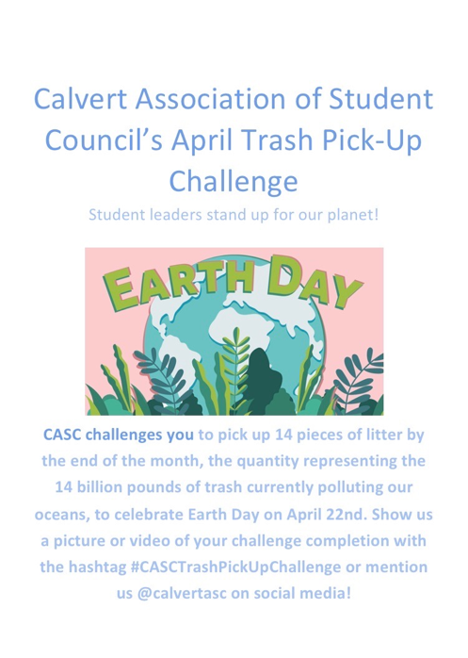

Use #CASCTrashPickUpChallenge

SMOB Report
Abby was not present to give her report.

MASC Report
Julianna was not present to give her report.

Advisor Report
Mr.Goldstein gave his report.

- Its necessary that you make sure everyone knows how the election works. We're the ambassadors for this. If you have a question ask Mr.Goldstein.
- Once we have elections finished a goal is to have a retreat this summer with the executive board.

Mr. Goldstein congratulated everyone for applying for an MASC executive board position.

Adjournment
Thomas adjourned the meeting at 6:56pm.

