CASC April General Assembly

Synopsis: The Calvert Association of Student Councils met on Friday April 23rd from 9am-1pm. During the meeting CASC held their election for the 2021-2022 Officers. The CASC awards were also announced. At the end of the meeting announcements were given.

- Call to Order
Thomas called the meeting to order at 9:07 on April 23rd and welcomed everyone to the meeting.

- Roll Call
All the schools were present.

- Secretary Speeches
The Secretary candidates gave their speeches in the following order.

Andrew Lieux- Plum Point Middle
Lily Windsor- Patuxent High School

- Secretary Q&A
Each candidate had 1 minute to answer each question.
The questions are as follows.

What made you choose to run for Secretary as opposed to another position and how will you use the responsibilities that are specific to the position to accomplish your goals?

If you were a candy bar what would you be?

How do you plan to manage your time with all the other responsibilities you may not have mentioned in you speech?

If you are absent who do you plan to use as your backup?

How do you plan to organize your materials and records? Will you keep physical records?

- Treasurer Speech
Natalie is a sophomore from Patuxent High school and she is the only candidate for Treasurer.

- Treasurer Q&A
The treasurer office only had one question from the current Treasurer.

- Mini Workshop #1
Students moved into their first 10 minute mini workshop of the day around 9:45.

- Second Vice President Speeches

Noah Gross- Plum Point Middle School
Allison Jones - Northern Middle School

- Second Vice President Q&A

They answered questions for their position. Some of them are listed below…

How do you plan to communicate without everyone outside of group chats and conference calls?

If you could be one mode of transportation what would you be?

What is your biggest weakness?

Do you play any sports or do any activities, if so how will they help you with this position?

- First Vice President Speeches
Addison Fortenbery- Northern High School
Madelynn Kelly- Plum Point Middle School

- First Vice President Q&A

The candidates answered questions about what they would do with the position.

- Mini Workshop #2
Students met in their second workshop of the day.

- President Speech
Thomas Foulkes- Huntingtown High School
Jenna Stahl- Patuxent High School

- President Q&A
Some of the questions for the session are listed below…

What is your plan to promote participation in schools especially those that are not active in CASC?

If you were a crayon what color would you be?

How much compassion do you have for your constituents?

How will you prioritize CASC?

- Voting
Students went into Caucuses to vote.

Andrew presented his video for the seniors of CASC and SGA.
It was Devante's idea to create a video for the seniors.

- SMOB report
Hayden the SMOB elect gave the SMOB report.

He attended the CCPS board retreat. He thanked the board for their hospitality and for letting him get involved so early. His term starts June 1st.

- Advisor Report

Awards
Outstanding Student Government-
High School- Northern High School
Middle School- Plum Point Middle

Outstanding Advisor-
Middle School- Mrs. Kelly Plum Point Middle
High School- Mrs. Jackson Northern High

Mr .Goldstein gave all his thanks to Mrs. Kelly and Ms.Lewis for all their help with the GA. As well as all the other advisors that helped out.

Mr. Goldstein talked about how tough of a decision student leader elections are and how proud he is of everyone who ran.

Election Winners
President- Jenna Stahl
Vice President- Madelynn Kelly
Secretary- Andrew Lieux
Treasurer- Natalie Shipman
Second Vice President- Noah Gross

- Announcements
Jenna Stahl announced the Division 5 conference for SGA on May 15th. Register on the MASC website.
Earth Day Announcement
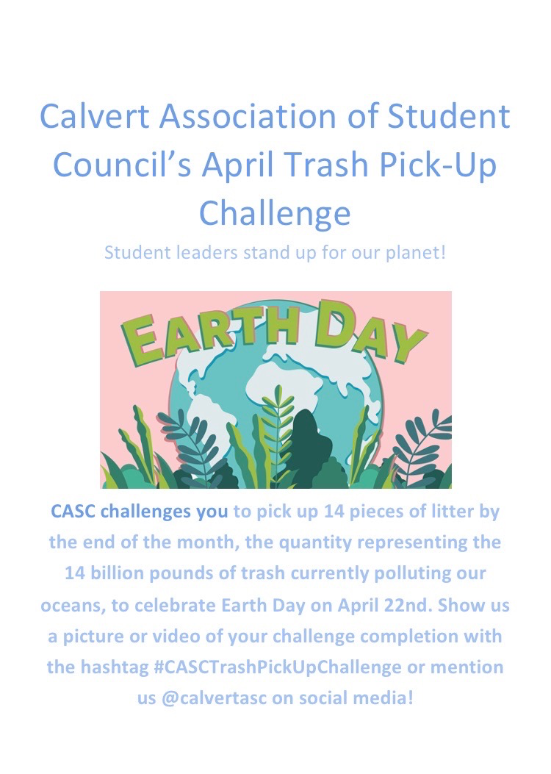

The meeting was adjourned at 12:13pm.
CASC Executive Board Applications are now open. Talk with your school advisor or contact an officer if interested.

