December 7th Executive Board Meeting
Minutes taken by Paige Plater the Secretary

Check the CASC Website for Officer and Executive Board Contact Information
https://calvertasc.weebly.com/

Synopsis: The Calvert Association of Student Councils meeting was held on
Monday December 7th, 2020. The meeting took place on teams. During the meeting CASC set their record for the year with 42 attendees from 9 of the schools. During the meeting we took part in a holiday outfit ice breaker and we discussed community service opportunities. Destiny introduced a mental health centered challenge for the month of December. We also discussed plans for the general assembly. We ended the meeting with the SMOB, MASC, and advisor reports. As well as some announcements from CASC members.

Present
Almost all of the executive board members were present. One of the evaluations coordinators and one of the SWCs were absent.

Did Each School have Representation. How many for the non- executive board member schools?
We had amazing representation. Unfortunately, one school still did not have representation for the non-executive board members. Our MASC divisional liaison also came.
Pax | Htown | NH | CH | SM | WHMS | PPMS | NMS | MCMS | CMS
2 | 1 | 2 | 3 | 3 | 1 | 1 | 3 | 0 | 1

- Call to order
Thomas called the meeting to order at 6:31.

- Approval of Agenda
The meeting agenda was approved with a motion and a call for unanimous consent.

- Community Service Announcement
Grace presented a community service idea. She and the other Community Service coordinators wanted to make sure there was interest in the event before reaching out to the organization.

- They're plan on reaching out to the American Chestnut Land trust to bring a small group of CASC members to volunteer,.

- When asked, some CASC members raised their hands to show their interest in participating.
- Grace added later in the meeting that if you're interested in participating in the upcoming community service event and there is a specific day that doesn’t work for you reach out to her and let her know.
- Let her know if there are any organizations that CASC can help out through community service projects.

- Energizer
-Holiday Outfit-
Everyone was asked to take 2 minutes and create a holiday outfit using what they had around their houses.

- New Business

- Destiny’s idea
Destiny announced her 20 for 20 pushup challenge. In this challenge you do either 20 pushups for 20 days or 1 pushup for 20 days during the month of December. Everyone was told to share this on their social medias.

This is to raise awareness for suicide prevention and mental health.

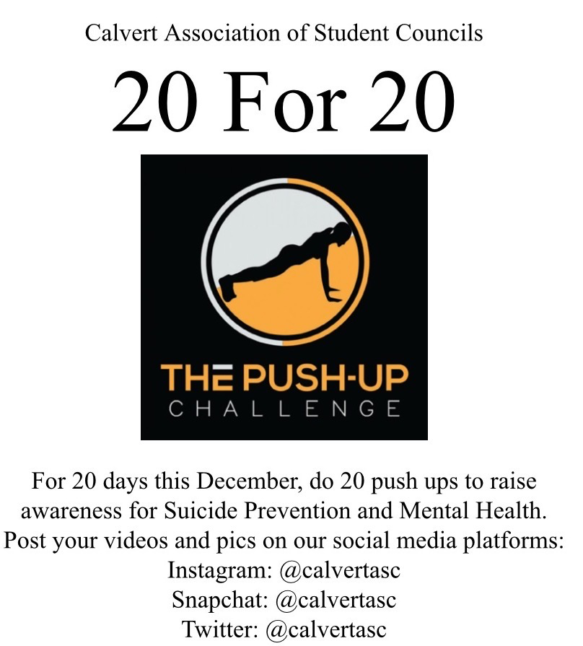

- GA discussion
- Thomas made sure everyone was okay with the 9-12 time slot for the second general assembly. Everyone agreed on the same time.

- Thomas talked about replacing the time used for the mock election at the last GA with multiple round tables.

- Round Tables: 3 topics middle and high school for each topic
Workshops: 7 or 8 workshops

- Mr. Goldstein talked about also whether he should place people in workshops or if they can go to it themselves.

Thomas talked about David's website mirroring MASC's FLC Launch page. David showed it to everyone.
- He included all of the information about CASC.

- He included flags to represent each workshop and incorporated the CASC 2020 theme "All Around the World."

- He also included a place to put the agenda and the public speakers' bios if needed.

- We discussed who would have access to the website and how everyone would join the meetings.

- Mr. Goldstein talked about having to schedule breakout meetings and put the links up on the website

Thomas gave an announcement about meeting with the Publication Coordinators sometime this week to discuss their newsletter for the GA (general assembly).

Kerra Miller the MASC Liaison gave an announcement about Leg Session coming up and the current need for a Division 5 middle school liaison.

Madelynn talked about starting back up her conference calls with middle school representatives.

- SMOB Report- Abby

- The board voted to pull k-2 from hybrid leaning and to not send 3-5 back to school.
- She believes its going to be harder to send back all students after the break but she understands it is to keep everyone safe.

Abby urged everyone to read the anti racism policy. There has been both good and bad feedback on it.

- She thinks it gives students comfort knowing the administration is behind them.. She wants everyone to let her know about their opinions on the policy.

- She is also asking continuing to ask everyone about their virtual learning experience
She talked about the difficulty in trying to represent everyone because everyone is having such a different experience with this virtual environment.

Mrs. Lewis spoke about creating a roundtable on the anti-racism topic. Mrs. Lewis thinks using that platform to talk about the policy will be a starting block for discussing the topic. She also added that the policy has a list of definitions that break down the words related to the topic for people to better understand.

- MASC Report

On December 12th MASC will hold their December Executive Board Meeting
- Registration closes Dec. 9
The registration link is on the MASC website
Email Julianna with questions (her contact information is on the CASC website)

Mr. Goldstein- Advisor Report

Mr. Goldstein shared his email he planned to send out to advisors about how to choose workshops.

- Everyone discussed how to find workshops and how to assign them.

- Thomas suggested sending out information on Wednesday for everyone to pick their workshops.

Mr. Goldstein talked about SMOB applications going out. Talk to your advisor if you're interested in the position of SMOB.

Mr. Goldstein expressed wanting to hold live speeches for the SMOB presentation.

- Everyone talked about having a live Q and A and the possibility of glitches. They pointed out that our last meeting had technical difficulties.

Abby talked about the board meetings being live and possibly seeing if the 4 candidates can give their speeches in person, social distanced, in a board room. We would live stream the speeches.

Mr.Goldstein talked about bringing it to his supervisor and asking him if that would be a possibility.

- Questions were asked about the livestream and if it would be through teams.

- They talked about embedding everything in the website

- They talked about the recording difficulties. Abby talked about possibly streaming it on the board website if there is an issue.

Maddy talked about her idea for screening the Q and A questions a certain way.

Someone asked for a review of the SMOB candidate requirements

SMOB Qualifications
Rising Junior or Senior
Qualify for Extra Curricular Activities

Goldstein clarified that the SMOB elections have to be at the GA.

I suggested possibly pre recording speeches as a backup if we aren’t able to livestream and the wifi cuts out for a SMOB candidate.

I thanked everyone for coming to the executive board meeting. I encouraged everyone to attend our events and fundraisers. I also encouraged everyone to come to more meetings so their voices can be heard.

Sheala gave an update on her inspirational video project
- Unfortunately she could not get photos from the elementary school videos because she was not allowed.
- She reached out to CASC members and asked them to send in pictures and videos with uplifting and encouraging messages for the elementary school kids. She did not get a lot of responses.
- She encouraged everyone to still try to send in those pictures and videos.
- The video will either be really short or postponed. She told everyone to check their emails. She will send out another email reminder soon.

Sheala clarified that the video or pictures should be to all the elementary schoolers in general. It can be a short video or a picture.

Thomas thanked everyone for coming and reminded everyone that the general assembly (ga) will be on December 18th.

Monday January 11th is the next executive board meeting.

Thomas adjourned the meeting at 7:32pm.

